Design of Chassis Antenna for Bug Robot Using Characteristic Mode Analysis

Jusun Won¹, Sangwook Nam^{1*}

¹School of Electrical and Computer Engineering and INMC, Seoul National University, Seoul 151-742, Korea

¹nexus@ael.snu.ac.kr, ^{1*}snam@snu.ac.kr
Abstract Designing multiple antennas in compact structure like small (operational use) bug robot model is a challenging due to several considerations. In this paper, practical mode exciter (booster) was presented for using a specific mode desired and verified with simulation results.

Keyword Characteristic Mode Analysis, Chassis Antenna, Booster, MIMO systems

- Introduction
A bug robot has been studied in many literatures and more recently, practical aerodynamic model was introduced by Harvard research team [1]. However, the implementation of antenna on the robot for communication has not been demonstrated effectively. It is relatively straight forward idea to attach antenna such as monopole, PIFA, etc., to robot model directly. However, it makes the bug robot bulky and aerodynamically inefficient because it should have a separate antenna structure. Another approach is to use bug body as an antenna by using Characteristic Mode Analysis (CMA) of the bug robot body. CMA is linear sum of real current modes determined by geometry of model and has property that each mode is orthogonal to the others [2]. To make better use of CMA, designers must consider coupler (booster) structure to excite the desired mode [3]. Recently, intuitive approach with slit structure was proposed [4] on mobile platform but applied it only simple plane to analyze.
In this paper we propose a novel H-shape structure (see Fig. 1(a)) to excite the desired mode (mode3) at 2.4GHz on a bug robot model (69.8mm × 52mm × 11mm, see Fig. 1(b))

- MIMO design : Simulation results
By using CMA, we can obtain three orthogonal Characteristic Modes on Bug robot model. Based on this, we can determine booster placement location to excite the mode we want to.
The H-shape slot structure are located on top and bottom of the wing support structure to enhance the mode excitation targeted. Our design uses FR4 (= 4.5), copper coating and has a compact size (10.6mm × 7mm). Applying this structure to a bug model, we successfully excited mode 3(see Fig. 2), constituting 96.12% of total current and holding FBW=12.26% (see Fig. 3)

- Conclusion
In this paper, Practical use of Characteristic Mode Analysis for designing of antenna was presented. According to the concept, we can use robot chassis as an antenna with booster which can excite specific mode needed.
Consequently the integration in the robot chassis with booster (H-shape) remove the need of external antenna for system. By using this structural approach and booster design, can lead the system more durable for operational environment, like desert or jungle.

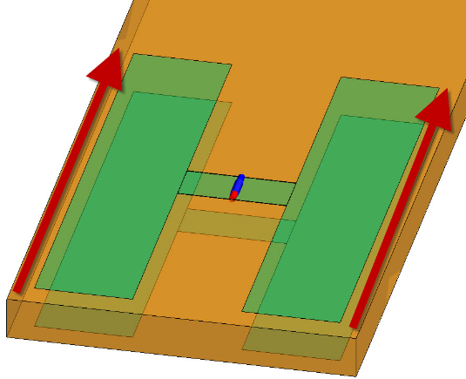
(a)
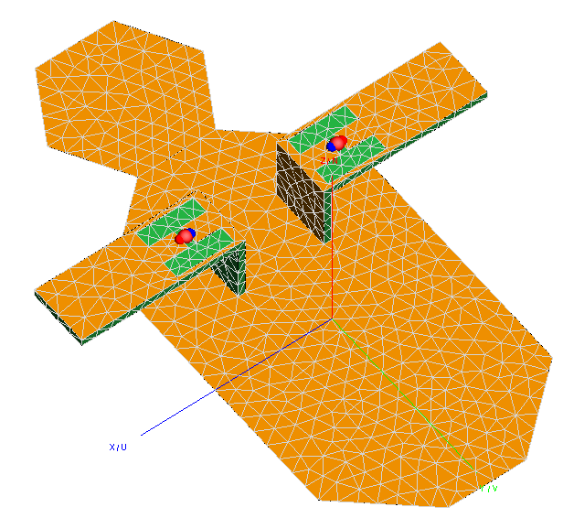
(b)
Fig. 1. (a) H-shape Booster, (b) Boosters on Bug robot model.

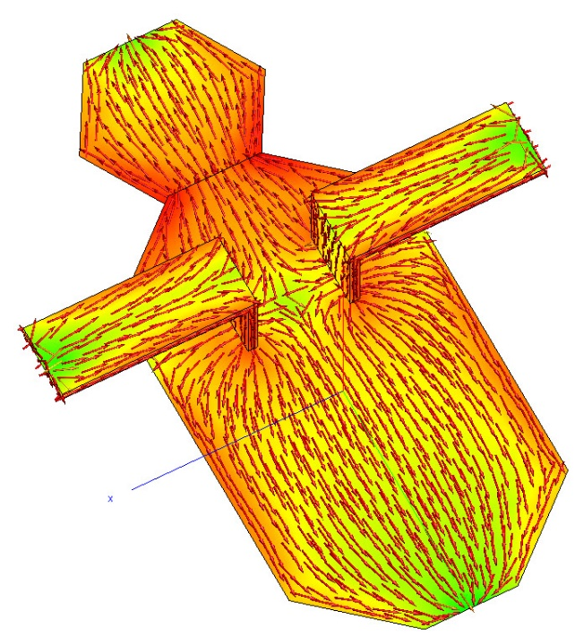
Fig. 2. Characteristic Mode Current (Mode 3).

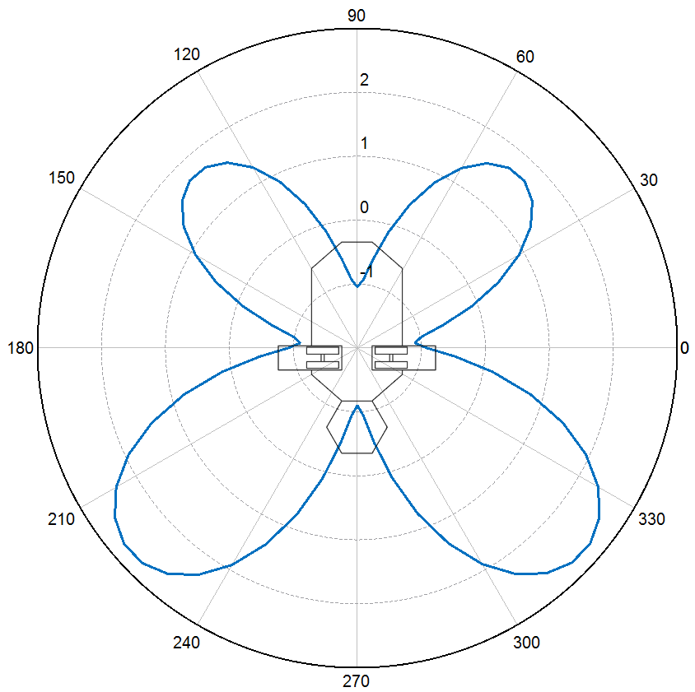
Fig. 3. Simulated E-plane Far-field patterns of proposed antenna

References
- Wood, R. J. The first takeoff of a biologically inspired at-scale robotic insect. IEEE. Trans. Rob. 24, 341–347 (2008).
- R. F. Harrington and J. R. Mautz, “Theory of characteristic modes for conducting bodies,” IEEE Trans. Antennas Propag., vol. AP-19, no. 5, pp. 622–628, Sep. 1971.
- A. Andujar, J. Anguera, and C. Puente, “Ground plane boosters as a compact antenna technology for wireless handheld devices,” IEEE Trans. Antennas Propag., vol. 59, no. 5, pp. 1668–1677, May 2011.
- R. Martens, D. Manteuffel, "Systematic Design Method of a Mobile Multiple Antenna System sing the Theory of Characteristic Modes," IET Microwaves, Antennas & Propagation, Volume 8, Issue 12, 16. Sept. 2014, pp. 887 – 893.

